Sample create page created-
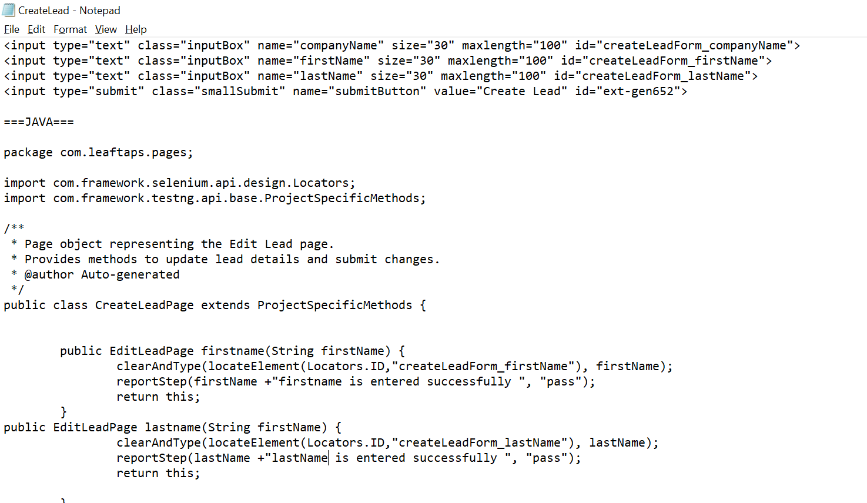

Add this in training data and run the Vs code
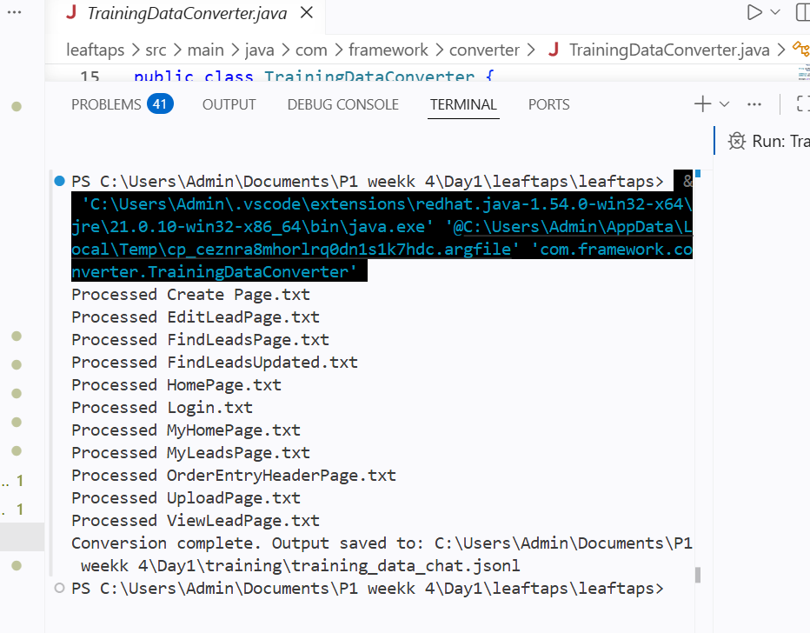
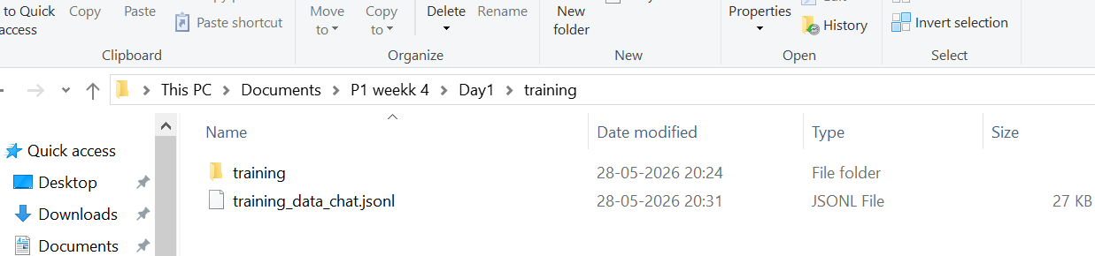
File upload-
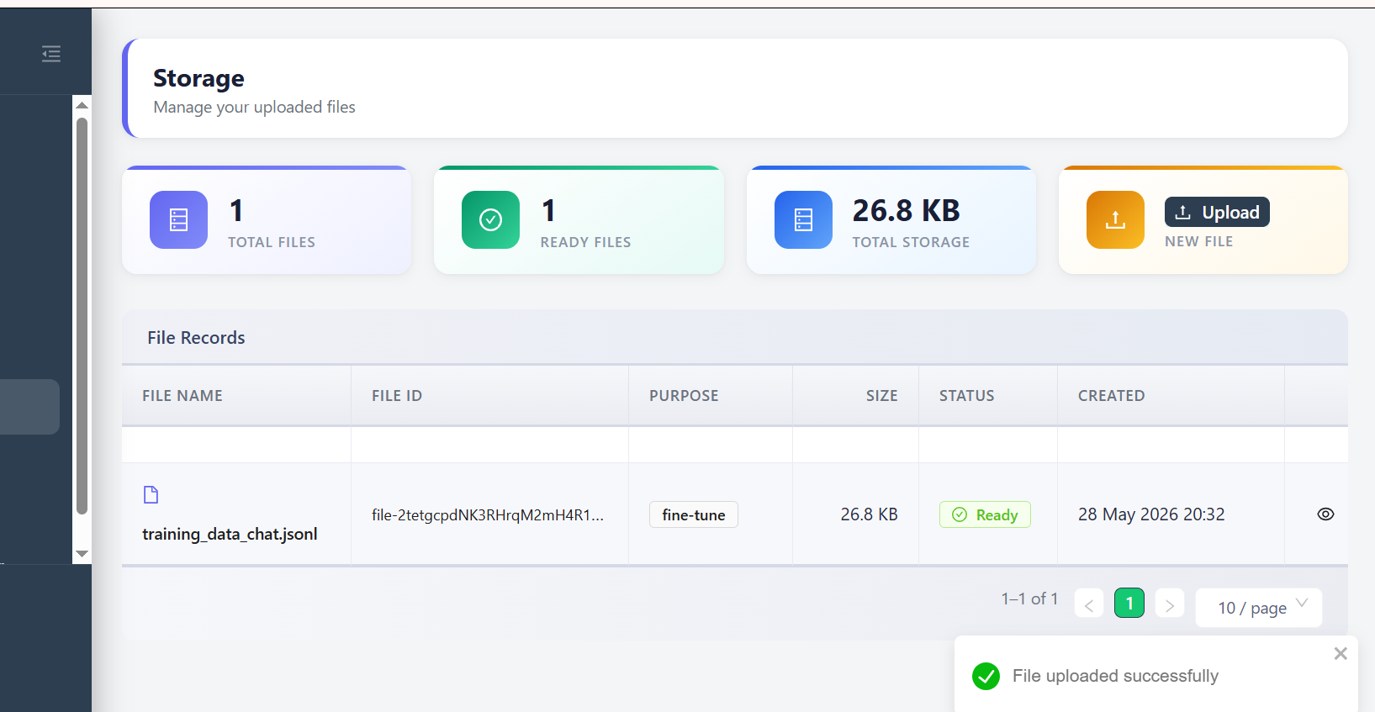
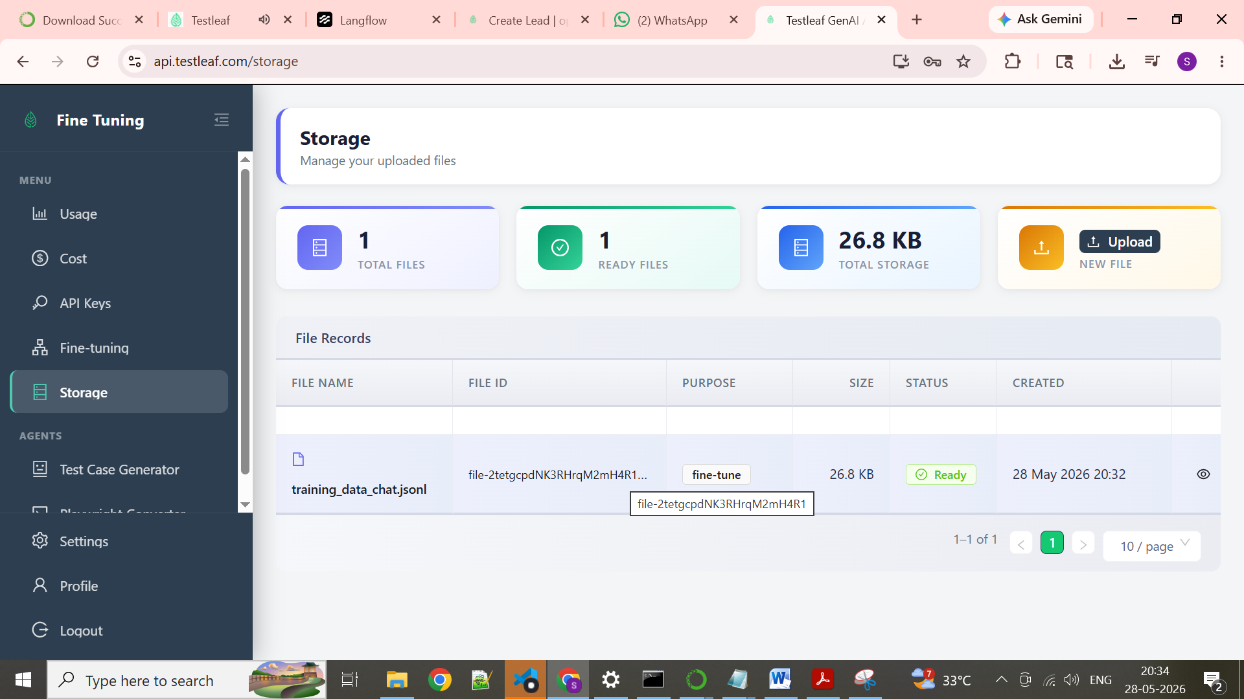

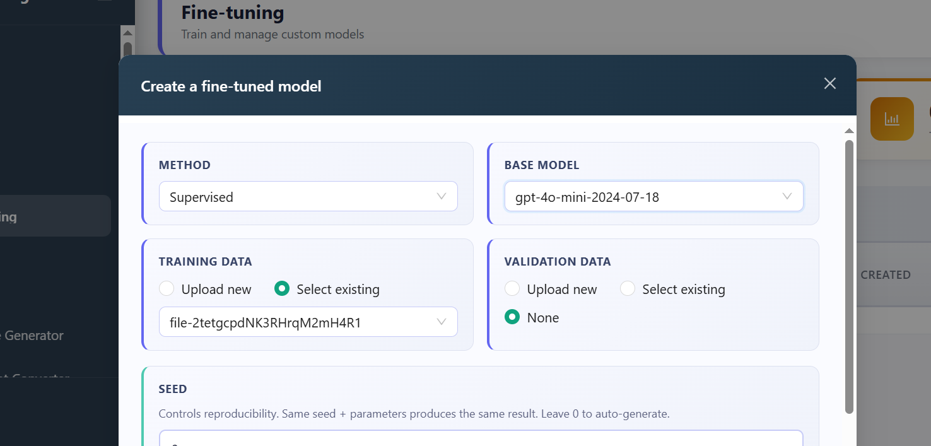

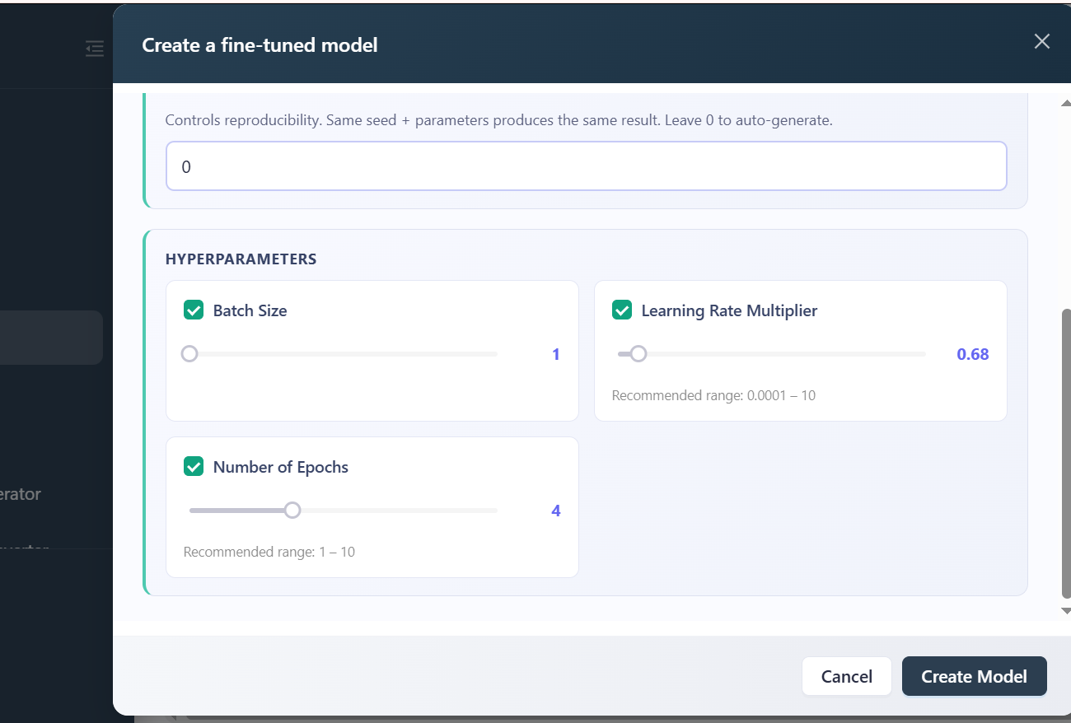

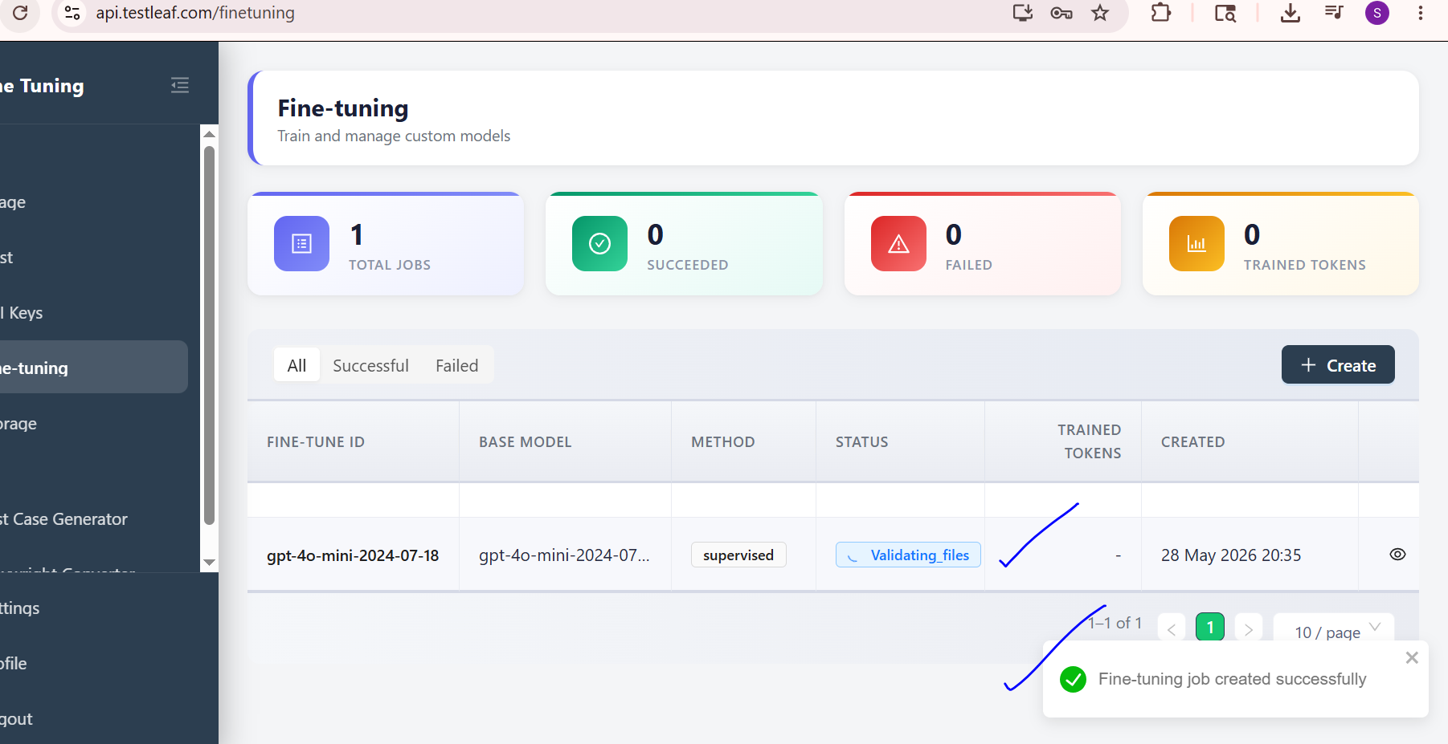

Output-
ft:gpt-4o-mini-2024-07-18:testleaf-2::DkeQ90qZ
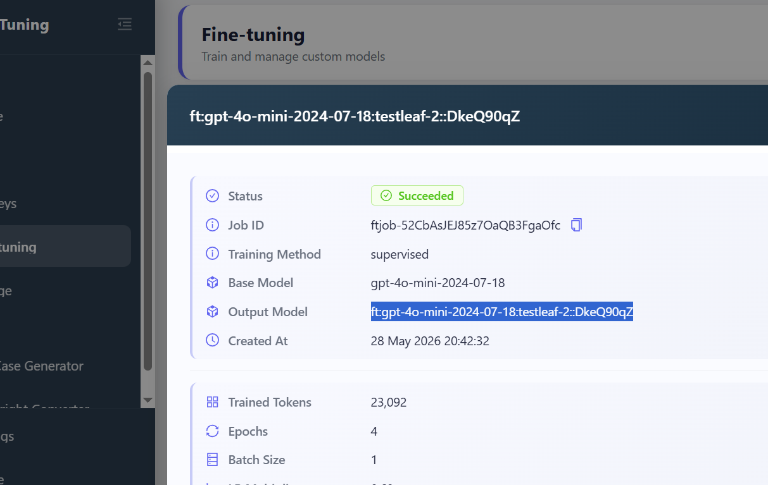

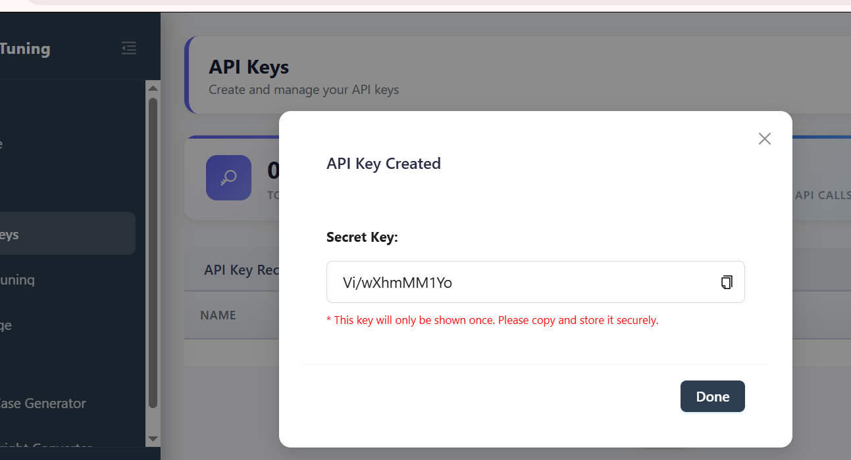

Reload AI extension and add above key
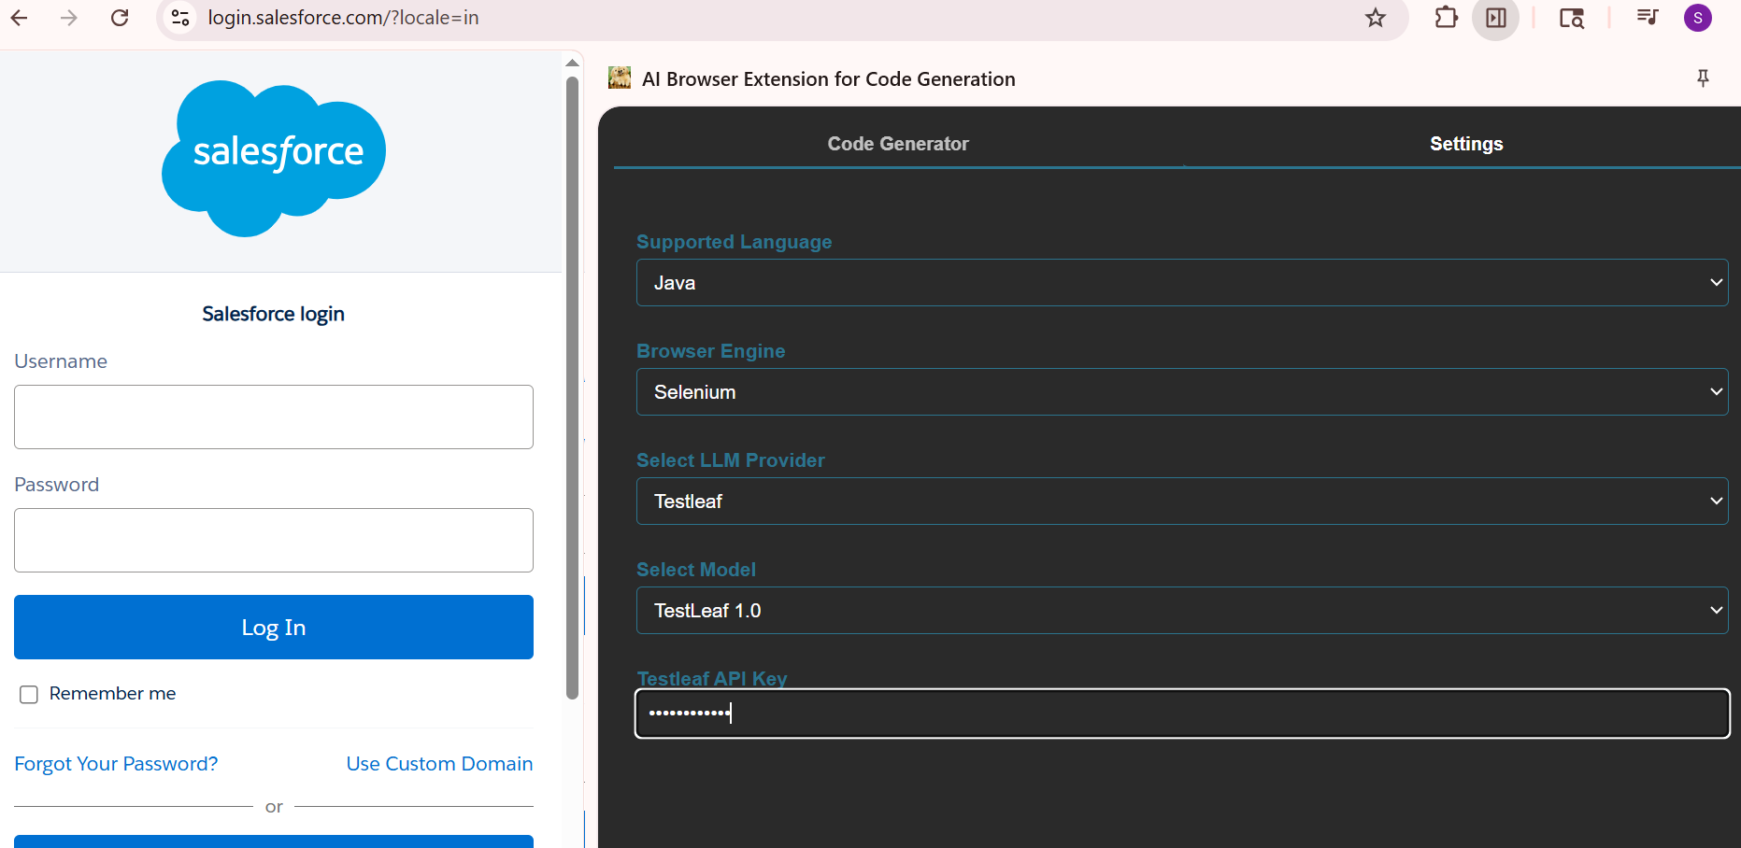

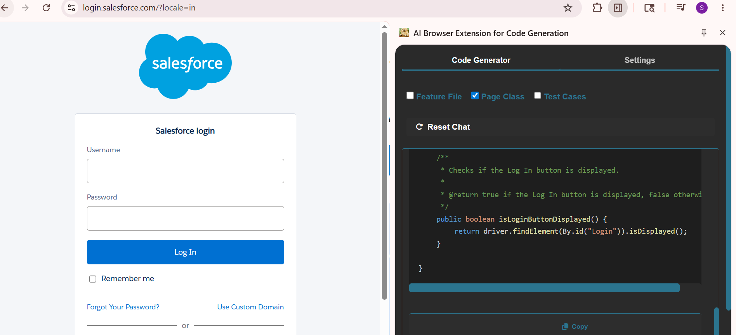

Output-
package com.testleaf.pages;

import org.openqa.selenium.By;
import org.openqa.selenium.remote.RemoteWebDriver;

/**
* Page Object representing the Salesforce Login Page.
* Provides methods to interact with the login form elements.
*/
public class LoginPage {

private final RemoteWebDriver driver;

/**
* Constructs a LoginPage instance.
*
* @param driver the WebDriver instance to use
*/
public LoginPage(RemoteWebDriver driver) {
this.driver = driver;
}

/**
* Enters the username in the login form.
*
* @param username the username to enter
* @return the current LoginPage instance
*/
public LoginPage enterUsername(String username) {
driver.findElement(By.id("username")).sendKeys(username);
return this;
}

/**
* Enters the password in the login form.
*
* @param password the password to enter
* @return the current LoginPage instance
*/
public LoginPage enterPassword(String password) {
driver.findElement(By.id("password")).sendKeys(password);
return this;
}

/**
* Clicks the Log In button to submit the login form.
*
* @return the current LoginPage instance
*/
public LoginPage clickLogin() {
driver.findElement(By.id("Login")).click();
return this;
}

/**
* Checks if the username field is displayed.
*
* @return true if the username field is displayed, false otherwise
*/
public boolean isUsernameFieldDisplayed() {
return driver.findElement(By.id("username")).isDisplayed();
}

/**
* Checks if the password field is displayed.
*
* @return true if the password field is displayed, false otherwise
*/
public boolean isPasswordFieldDisplayed() {
return driver.findElement(By.id("password")).isDisplayed();
}

/**
* Checks if the Log In button is displayed.
*
* @return true if the Log In button is displayed, false otherwise
*/
public boolean isLoginButtonDisplayed() {
return driver.findElement(By.id("Login")).isDisplayed();
}

}

